**UNIT-2**

**(Wireless) Medium Access Control :** Motivation for a specialized MAC (Hidden and exposed terminals, Near and far terminals), SDMA, FDMA, TDMA, CDMA.MAC protocols for GSM , collision Avoidance (MACA, MACAW) protocols

**Mobile IP Network Layer :** IP Mobile IP Network layers, packet delivery and handover management, location management registration, tunneling and encapsulation, Route optimizations, Dynamic Host Configuration Protocol (DHCP).

**Mobile Transport Layer :** Conventional TCP/IP protocols, Indirect TCP, Snooping TCP, Mobile TCP, other Transport Layer protocols for Mobile Networks.

**Unit:2**

The **Media Access Control** (**MAC**) data communication protocol sub-layer, also known as the Medium Access Control, is a sublayer of the Data Link Layer specified in the seven-layer OSI model (layer 2). The hardware that implements the MAC is referred to as a **Medium Access Controller**. The MAC sub-layer acts as an interface between the Logical Link Control (LLC) sublayer and the network's physical layer. The MAC layer emulates a full-duplex logical communication channel in a multi-point network. This channel may provide unicast, multicast or broadcast communication service.

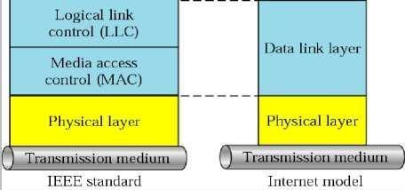

***LLC and MAC sublayers***

**Motivation for a specialized MAC**

One of the most commonly used MAC schemes for wired networks is carrier sense multiple access with collision detection (CSMA/CD). In this scheme, a sender senses the medium (a wire or coaxial cable) to see if it is free. If the medium is busy, the sender waits until it is free. If the medium is free, the sender starts transmitting data and continues to listen into the medium. If the sender detects a collision while sending, it stops at once and sends a jamming signal. But this scheme doest work well with wireless networks. The problems are:

* + Signal strength decreases proportional to the square of the distance
  + The sender would apply CS and CD, but the collisions happen at the receiver
  + It might be a case that a sender cannot ―hear‖ the collision, i.e., CD does not work
  + Furthermore, CS might not work, if for e.g., a terminal is ―hidden‖

Hidden and Exposed Terminal

Consider the scenario with three mobile phones as shown below. The transmission range of A reaches B, but not C (the detection range does not reach C either). The transmission range of C reaches B, but not A. Finally, the transmission range of B reaches A and C, i.e., A cannot detect C and vice versa.

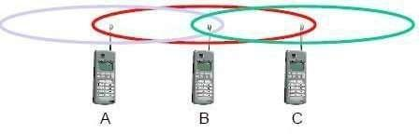

***Hidden terminals***

* A sends to B, C cannot hear A
* C wants to send to B, C senses a ―free‖ medium (CS fails) and starts transmitting
* Collision at B occurs, A cannot detect this collision (CD fails) and continues with its transmission to B
* A is ―hidden‖ from C and vice versa

***Exposed terminals***

* B sends to A, C wants to send to another terminal (not A or B) outside the range
* C senses the carrier and detects that the carrier is busy.
* C postpones its transmission until it detects the medium as being idle again
* but A is outside radio range of C, waiting is **not** necessary
* C is ―exposed‖ to B

Hidden terminals cause collisions, where as Exposed terminals causes unnecessary delay.

Near and far terminals

Consider the situation shown below. A and B are both sending with the same transmission power.

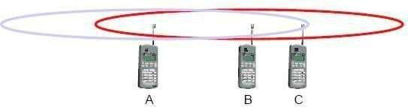

* Signal strength decreases proportional to the square of the distance
* So, B‘s signal drowns out A‘s signal making C unable to receive A‘s transmission
* If C is an arbiter for sending rights, B drown out A‘s signal on the physical layer making C unable to hear out A.

The **near/far effect** is a severe problem of wireless networks using CDM. All signals should arrive at the receiver with more or less the same strength for which Precise power control is to be implemented.

**SDMA**

**Space Division Multiple Access (SDMA)** is used for allocating a separated space to users in wireless networks. A typical application involves assigning an optimal base station to a mobile phone

user. The mobile phone may receive several base stations with different quality. A MAC algorithm could now decide which base station is best, taking into account which frequencies

(FDM), time slots (TDM) or code (CDM) are still available. The basis for the SDMA algorithm is formed by cells and sectorized antennas which constitute the infrastructure implementing **space division multiplexing (SDM).** SDM has the unique advantage of not requiring any multiplexing equipment. It is usually combined with other multiplexing techniques to better utilize the individual physical channels.

**FDMA**

Frequency division multiplexing (FDM) describes schemes to subdivide the frequency dimension into several non-overlapping frequency bands.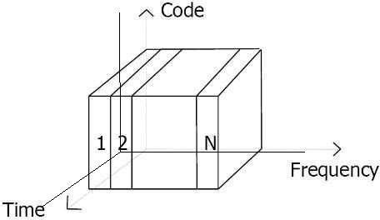

Frequency Division Multiple Access is a method employed to permit several users to transmit simultaneously on one satellite transponder by assigning a specific frequency within the channel to each user. Each conversation gets its own, unique, radio channel. The channels are relatively narrow, usually 30 KHz or less and are defined as either transmit or receive channels. A full duplex conversation requires a transmit & receive channel pair. FDM is often used for simultaneous access to the medium by base station and mobile station in cellular networks establishing a duplex channel. A scheme called **frequency division duplexing (FDD)** in which the two directions, mobile station to base station and vice versa are now separated using different frequencies.

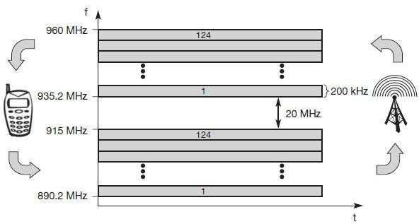

***FDM for multiple access and duplex***

The two frequencies are also known as **uplink**, i.e., from mobile station to base station or from ground control to satellite, and as **downlink**, i.e., from base station to mobile station or from

satellite to ground control. The basic frequency allocation scheme for GSM is fixed and regulated by national authorities. All uplinks use the band between 890.2 and 915 MHz, all downlinks use 935.2 to 960 MHz. According to FDMA, the base station, shown on the right side, allocates a certain frequency for up- and downlink to establish a duplex channel with a mobile phone. Up- and downlink have a fixed relation. If the uplink frequency is fu = 890 MHz + n· 0.2 MHz, the downlink frequency is fd = fu + 45 MHz,

* **., fd = 935 MHz + n· 0.2 MHz** for a certain channel n. The base station selects the channel. Each channel (uplink and downlink) has a bandwidth of 200 kHz.

This scheme also has disadvantages. While radio stations broadcast 24 hours a day, mobile communication typically takes place for only a few minutes at a time. Assigning a separate frequency for each possible communication scenario would be a tremendous waste of (scarce) frequency resources. Additionally, the fixed assignment of a frequency to a sender makes the scheme very inflexible and limits the number of senders.

**TDMA**

A more flexible multiplexing scheme for typical mobile communications is time division multiplexing (TDM). Compared to FDMA, time division multiple access (TDMA) offers a much more flexible scheme, which comprises all technologies that allocate certain time slots for communication. Now synchronization between sender and receiver has to be achieved in the time domain. Again this can be done by using a fixed pattern similar to FDMA techniques, i.e., allocating a certain time slot for a channel, or by using a dynamic allocation scheme.

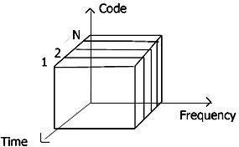

Listening to different frequencies at the same time is quite difficult, but listening to many channels separated in time at the same frequency is simple. Fixed schemes do not need identification, but are not as flexible considering varying bandwidth requirements.

***Fixed TDM***

The simplest algorithm for using TDM is allocating time slots for channels in a fixed pattern. This results in a fixed bandwidth and is the typical solution for wireless phone systems. MAC is quite simple, as the only crucial factor is accessing the reserved time slot at the right moment. If this synchronization is assured, each mobile station knows its turn and no interference will happen. The fixed pattern can be assigned by the base station, where competition between different mobile stations that want to access the medium is solved.

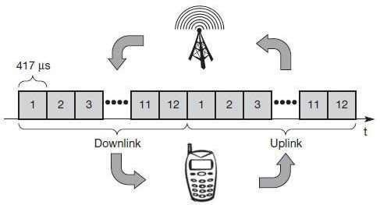

The above figure shows how these fixed TDM patterns are used to implement multiple access and a duplex channel between a base station and mobile station. Assigning different slots for uplink and downlink using the same frequency is called **time division duplex (TDD)**. As shown in the figure, the base station uses one out of 12 slots for the downlink, whereas the mobile station uses one out of 12 different slots for the uplink. Uplink and downlink are separated in time. Up to 12 different mobile stations can use the same frequency without interference using this scheme. Each connection is allotted its own up- and downlink pair. This general scheme still wastes a lot of bandwidth. It is too static, too inflexible for data communication. In this case, connectionless, demand-oriented TDMA schemes can be used

Classical Aloha

In this scheme, TDM is applied without controlling medium access. Here each station can access the medium at any time as shown below: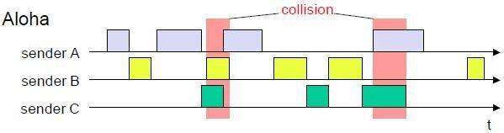

This is a random access scheme, without a central arbiter controlling access and without coordination among the stations. If two or more stations access the medium at the same time, a **collision** occurs and the transmitted data is destroyed. Resolving this problem is left to higher layers (e.g., retransmission of data). The simple Aloha works fine for a light load and does not require any complicated access mechanisms.

***Slotted Aloha***

The first refinement of the classical Aloha scheme is provided by the introduction of time slots (**slotted Aloha**). In this case, all senders have to be **synchronized**, transmission can only start at the beginning of a **time slot** as shown below.

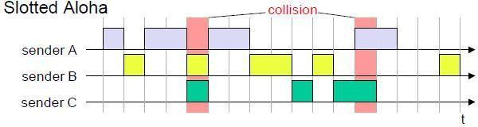

The introduction of slots raises the throughput from 18 per cent to 36 per cent, i.e., slotting doubles the throughput. Both basic Aloha principles occur in many systems that implement distributed access to a medium. Aloha systems work perfectly well under a light load, but they cannot give any hard transmission guarantees, such as maximum delay before accessing the medium or minimum throughput.

***Carrier sense multiple access***

One improvement to the basic Aloha is sensing the carrier before accessing the medium. Sensing the carrier and accessing the medium only if the carrier is idle decreases the probability of a collision. But, as already mentioned in the introduction, hidden terminals cannot be detected, so, if a hidden terminal transmits at the same time as another sender, a collision might occur at the receiver. This basic scheme is still used in most wireless LANs. The different versions of CSMA are:

* **1-persistent CSMA**: Stations sense the channel and listens if its busy and transmit immediately, when the channel becomes idle. It‘s called 1-persistent CSMA because the host transmits with a probability of 1 whenever it finds the channel idle.
* **non-persistent CSMA**: stations sense the carrier and start sending immediately if the medium is idle. If the medium is busy, the station pauses a random amount of time before sensing the medium again and repeating this pattern.
* **p-persistent CSMA**: systems nodes also sense the medium, but only transmit with a probability of p, with the station deferring to the next slot with the probability 1-p, i.e., access is slotted in addition

CSMA with collision avoidance (**CSMA/CA**) is one of the access schemes used in wireless LANs following the standard IEEE 802.11. Here sensing the carrier is combined with a back-off scheme in case of a busy medium to achieve some fairness among competing stations.

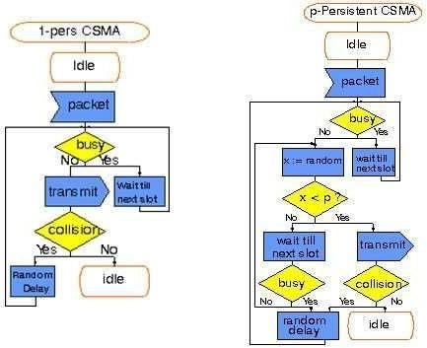

***Demand assigned multiple access***

Channel efficiency for Aloha is 18% and for slotted Aloha is 36%. It can be increased to 80% by implementing reservation mechanisms and combinations with some (fixed) TDM patterns. These schemes typically have a reservation period followed by a transmission period. During the reservation period, stations can reserve future slots in the transmission period. While, depending on the scheme, collisions may occur during the reservation period, the transmission period can then be accessed without collision.

One basic scheme is **demand assigned multiple access (DAMA)** also called **reservation Aloha**, a scheme typical for satellite systems. It increases the amount of users in a pool of satellite channels that are available for use by any station in a network. It is assumed that not all users will need simultaneous access to the same communication channels. So that a call can be established, DAMA assigns a pair of available channels based on requests issued from a user. Once the call is completed, the channels are returned to the pool for an assignment to another call. Since the resources of the satellite are being used only in proportion to the occupied channels for the time in which they are being held, it is a perfect environment for voice traffic and data traffic in batch mode.

It has two modes as shown below.

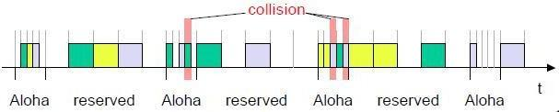

During a contention phase following the slotted Aloha scheme; all stations can try to reserve future slots. Collisions during the reservation phase do not destroy data transmission, but only the short requests for data transmission. If successful, a time slot in the future is reserved, and no other station is allowed to transmit during this slot. Therefore, the satellite collects all successful requests (the others are destroyed) and sends back a reservation list indicating access rights for

future slots. All ground stations have to obey this list. To maintain the fixed TDM pattern of reservation and transmission, the stations have to be synchronized from time to time. DAMA is

an **explicit reservation** scheme. Each transmission slot has to be reserved explicitly.

***PRMA packet reservation multiple access***

It is a kind of implicit reservation scheme where, slots can be reserved implicitly. A certain number of slots form a frame. The frame is repeated in time i.e., a fixed TDM pattern is applied. A base station, which could be a satellite, now broadcasts the status of each slot to all mobile stations. All stations receiving this vector will then know which slot is occupied and which slot is currently free.

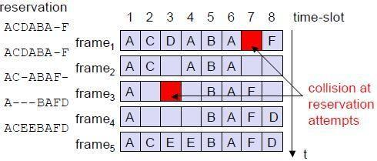

The base station broadcasts the reservation status ‗ACDABA-F‘ to all stations, here A to

F. This means that slots one to six and eight are occupied, but slot seven is free in the following transmission. All stations wishing to transmit can now compete for this free slot in Aloha fashion. The already occupied slots are not touched. In the example shown, more than one station wants to access this slot, so a collision occurs. The base station returns the reservation status ‗ACDABA- F‘, indicating that the reservation of slot seven failed (still indicated as free) and that nothing has changed for the other slots. Again, stations can compete for this slot. Additionally, station D has stopped sending in slot three and station F in slot eight. This is noticed by the base station after the second frame. Before the third frame starts, the base station indicates that slots three and eight are now idle. Station F has succeeded in reserving slot seven as also indicated by the base station.

As soon as a station has succeeded with a reservation, all future slots are implicitly reserved for this station. This ensures transmission with a guaranteed data rate. The slotted aloha scheme is used for idle slots only; data transmission is not destroyed by collision.

***Reservation TDMA***

In a fixed TDM scheme N mini-slots followed by N·k data-slots form a frame that is repeated. Each station is allotted its own mini-slot and can use it to reserve up to k data-slots.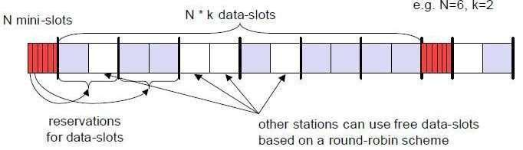

This guarantees each station a certain bandwidth and a fixed delay. Other stations can now send data in unused data-slots as shown. Using these free slots can be based on a simple round-robin scheme or can be uncoordinated using an Aloha scheme. This scheme allows for the combination of, e.g., isochronous traffic with fixed bitrates and best-effort traffic without any guarantees.

***Multiple access with collision avoidance***

Multiple access with collision avoidance (MACA) presents a simple scheme that solves the hidden terminal problem, does not need a base station, and is still a random access Aloha scheme

– but with dynamic reservation. Consider the hidden terminal problem scenario.

A starts sending to B, C does not receive this transmission. C also wants to send something to B and senses the medium. The medium appears to be free, the carrier sense fails. C also starts sending causing a collision at B. But A cannot detect this collision at B and continues with its transmission. A is **hidden** for C and vice versa.

With MACA, A does not start its transmission at once, but sends a **request to send (RTS)** first. B receives the RTS that contains the name of sender and receiver, as well as the length of the future transmission. This RTS is not heard by C, but triggers an acknowledgement from B, called **clear to send (CTS)**. The CTS again contains the names of sender (A) and receiver (B) of the user data, and the length of the future transmission.

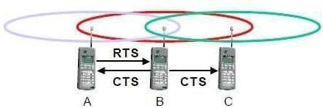

This CTS is now heard by C and the medium for future use by A is now reserved for the duration of the transmission. After receiving a CTS, C is not allowed to send anything for the duration indicated in the CTS toward B. A collision cannot occur at B during data transmission, and the hidden terminal problem is solved. Still collisions might occur when A and C transmits a RTS at the same time. B resolves this contention and acknowledges only one station in the CTS. No transmission is allowed without an appropriate CTS.

Now MACA tries to avoid the **exposed terminals** in the following way:

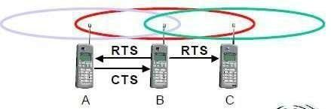

With MACA, B has to transmit an RTS first containing the name of the receiver (A) and the sender (B). C does not react to this message as it is not the receiver, but A acknowledges using a CTS which identifies B as the sender and A as the receiver of the following data

transmission. C does not receive this CTS and concludes that A is outside the detection range. C can start its transmission assuming it will not cause a collision at A. The problem with exposed terminals is solved without fixed access patterns or a base station.

**Polling**

Polling schemes are used when one station wants to be heard by others. Polling is a strictly centralized scheme with one master station and several slave stations. The master can poll the slaves according to many schemes: round robin (only efficient if traffic patterns are similar over all stations), randomly, according to reservations (the classroom example with polite students) etc. The master could also establish a list of stations wishing to transmit during a contention phase. After this phase, the station polls each station on the list. Example: Randomly Addressed Polling

* base station signals readiness to all mobile terminals
* terminals ready to send transmit random number without collision using CDMA or FDMA
* the base station chooses one address for polling from list of all random numbers (collision if two terminals choose the same address)
* the base station acknowledges correct packets and continues polling the next terminal
* this cycle starts again after polling all terminals of the list

**Inhibit sense multiple access**

This scheme, which is used for the packet data transmission service Cellular Digital Packet Data (CDPD) in the AMPS mobile phone system, is also known as **digital sense multiple access (DSMA)**. Here, the base station only signals a busy medium via a busy tone (called BUSY/IDLE indicator) on the downlink.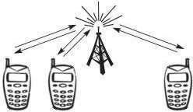

After the busy tone stops, accessing the uplink is not coordinated any further. The base station acknowledges successful transmissions; a mobile station detects a collision only via the missing positive acknowledgement. In case of collisions, additional back-off and retransmission mechanisms are implemented.

**CDMA**

Code division multiple access systems apply codes with certain characteristics to the transmission to separate different users in code space and to enable access to a shared medium without interference.

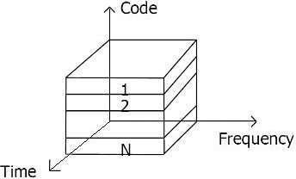

All terminals send on the same frequency probably at the same time and can use the whole bandwidth of the transmission channel. Each sender has a unique random number, the sender XORs the signal with this random number. The receiver can ―tune‖ into this signal if it knows the pseudo random number, tuning is done via a correlation function

Disadvantages:

* + higher complexity of a receiver (receiver cannot just listen into the medium and start receiving if there is a signal)
  + all signals should have the same strength at a receiver
  + all terminals can use th3e2same frequency, no planning needed
  + huge code space (e.g. 2 ) compared to frequency space
  + interferences (e.g. white noise) is not coded
  + forward error correction and encryption can be easily integrated

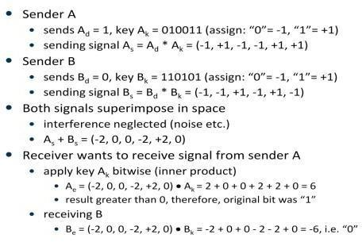

The following figure shows a sender A that wants to transmit the bits 101. The key of A is shown as signal and binary sequence Ak. The binary “0” is assigned a positive signal value, the binary “1” a negative signal value. After spreading, i.e., XORing Ad and Ak, the resulting signal is As.

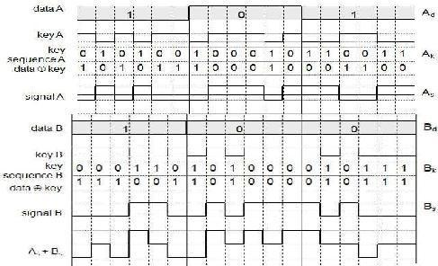

***Coding and spreading of data from sender A and sender B***

The same happens with data from sender B with bits 100. The result is Bs. As and Bs now superimpose during transmission. The resulting signal is simply the sum As + Bs as shown above. A now tries to reconstruct the original data from Ad. The receiver applies A‘s key, Ak, to the received signal and feeds the result into an integrator. The integrator adds the products, a comparator then has to decide if the result is a 0 or a 1 as shown below. As clearly seen, although the original signal form is distorted by B‘s signal, the result is quite clear. The same happens if a receiver wants to receive B‘s data.

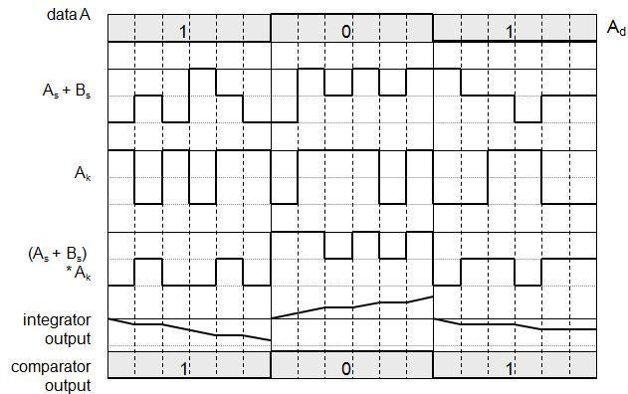

***Reconstruction of A’s data***

**Soft handover** or **soft handoff** refers to a feature used by the CDMA and WCDMA standards, where a cell phone is simultaneously connected to two or more cells (or cell sectors) during a call. If the sectors are from the same physical cell site (a sectorised site), it is referred to as **softer handoff**. This technique is a form of mobile-assisted handover, for IS-95/CDMA2000 CDMA cell phones continuously make power measurements of a list of neighboring cell sites, and determine whether or not to request or end soft handover with the cell sectors on the list.

Soft handoff is different from the traditional hard-handoff process. With hard handoff, a definite decision is made on whether to hand off or not. The handoff is initiated and executed without the user attempting to have simultaneous traffic channel communications with the two base stations. With soft handoff, a c*onditional* decision is made on whether to hand off. Depending on the changes in pilot signal strength from the two or more base stations involved, a hard decision will eventually be made to communicate with only one. This normally happens after it is evident that the signal from one base station is considerably stronger than those from the others. In the interim period, the user has simultaneous traffic channel communication with all candidate base stations. It is desirable to implement soft handoff in power-controlled CDMA systems because implementing hard handoff is potentially difficult in such systems.

**Spread Aloha multiple access (SAMA)**

CDMA senders and receivers are not really simple devices. Communicating with *n* devices requires programming of the receiver to be able to decode *n* different codes. Aloha was a very simple scheme, but could only provide a relatively low bandwidth due to collisions. SAMA uses spread spectrum with only one single code (chipping sequence) for spreading for all senders accessing according to aloha.

In SAMA, each sender uses the same spreading code, for ex 110101 as shown below. Sender A and B access the medium at the same time in their narrowband spectrum, so that the three bits shown causes collisions. The same data could also be sent with higher power for shorter periods as show.

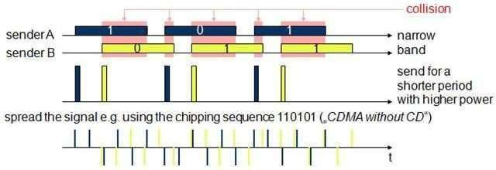

The main problem in using this approach is finding good chipping sequences. The maximum throughput is about 18 per cent, which is very similar to Aloha, but the approach benefits from the advantages of spread spectrum techniques: robustness against narrowband interference and simple coexistence with other systems in the same frequency band.

**MOBILE NETWORK LAYER**

***Need for Mobile IP***

The IP addresses are designed to work with stationary hosts because part of the address defines the network to which the host is attached***.*** A host cannot change its IP address without terminating on-going sessions and restarting them after it acquires a new address. Other link layer mobility solutions exist but are not sufficient enough for the global Internet.

*Mobility* is the ability of a node to change its point-of-attachment while maintaining all existing communications and using the same IP address.

*Nomadicity* allows a node to move but it must terminate all existing communications and then can initiate new connections with a new address.

*Mobile IP is a network layer solution for homogenous and heterogeneous mobility on the global Internet which is scalable, robust, secure and which allows nodes to maintain all ongoing communications while moving.*

**Design Goals**: Mobile IP was developed as a means for transparently dealing with problems of mobile users. Mobile IP was designed to make the size and the frequency of required routing updates as small as possible. It was designed to make it simple to implement mobile node software. It was designed to avoid solutions that require mobile nodes to use multiple addresses.

**Requirements**: There are several requirements for Mobile IP to make it as a standard. Some of them are:

* + *Compatibility*: The whole architecture of internet is very huge and a new standard cannot introduce changes to the applications or network protocols already in use. Mobile IP is to be integrated into the existing operating systems. Also, for routers also it may be possible to enhance its capabilities to support mobility instead of changing the routers which is highly impossible. Mobile IP must not require special media or MAC/LLC protocols, so it must use the same interfaces and mechanisms to access the lower layers as IP does. Finally, end-systems enhanced with a mobile IP implementation should still be able to communicate with fixed systems without mobile IP.
  + *Transparency*: Mobility remains invisible for many higher layer protocols and applications. Higher layers continue to work even if the mobile computer has changed its point of attachment to the network and even notice a lower bandwidth and some interruption in the service. As many of today‘s applications have not been designed to use in mobile environments, the effects of mobility will be higher delay and lower bandwidth.
  + *Scalability and efficiency*: The efficiency of the network should not be affected even if a new mechanism is introduced into the internet. Enhancing IP for mobility must not generate many new messages flooding the whole network. Special care is necessary to be taken considering the lower bandwidth of wireless links. Many mobile systems have a wireless link to an attachment point. Therefore, only some additional packets must be necessary between a mobile system and a node in the network. It is indispensable for a mobile IP to be scalable over a large number of participants in the whole internet, throughout the world.
  + *Security*: Mobility possesses many security problems. A minimum requirement is the authentication of all messages related to the management of mobile IP. It must be sure for the IP layer if it forwards a packet to a mobile host that this host really is the receiver of the packet. The IP layer can only guarantee that the IP address of the receiver is correct. There is no way to prevent faked IP addresses and other attacks.

The goal of a mobile IP can be summarized as: ‗supporting end-system mobility while maintaining scalability, efficiency, and compatibility in all respects with existing applications and Internet protocols‘.

**Entities and terminology**

The following defines several entities and terms needed to understand mobile IP as defined in RFC 3344.

#### ➢

**Mobile Node (MN):** A mobile node is an end-system or router that can change its

point of attachment to the internet using mobile IP. The MN keeps its IP address and can continuously communicate with any other system in the internet as long as link- layer connectivity is given. Examples are laptop, mobile phone, router on an aircraft etc.

#### ➢

**Correspondent node (CN):** At least one partner is needed for communication. In the following the CN represents this partner for the MN. The CN can be a fixed or mobile node.

#### ➢

**Home network:** The home network is the subnet the MN belongs to with respect to its IP address. No mobile IP support is needed within the home network.

#### ➢

**Foreign network:** The foreign network is the current subnet the MN visits and which is not the home network.

#### ➢

**Foreign agent (FA):** The FA can provide several services to the MN during its visit

to the foreign network. The FA can have the COA, acting as tunnel endpoint and forwarding packets to the MN. The FA can be the default router for the MN. FAs can also provide security services because they belong to the foreign network as opposed to the MN which is only visiting. FA is implemented on a router for the subnet the MN attaches to.

#### ➢

**Care-of address (COA):** The COA defines the current location of the MN from an IP

point of view. All IP packets sent to the MN are delivered to the COA, not directly to the IP address of the MN. Packet delivery toward the MN is done using

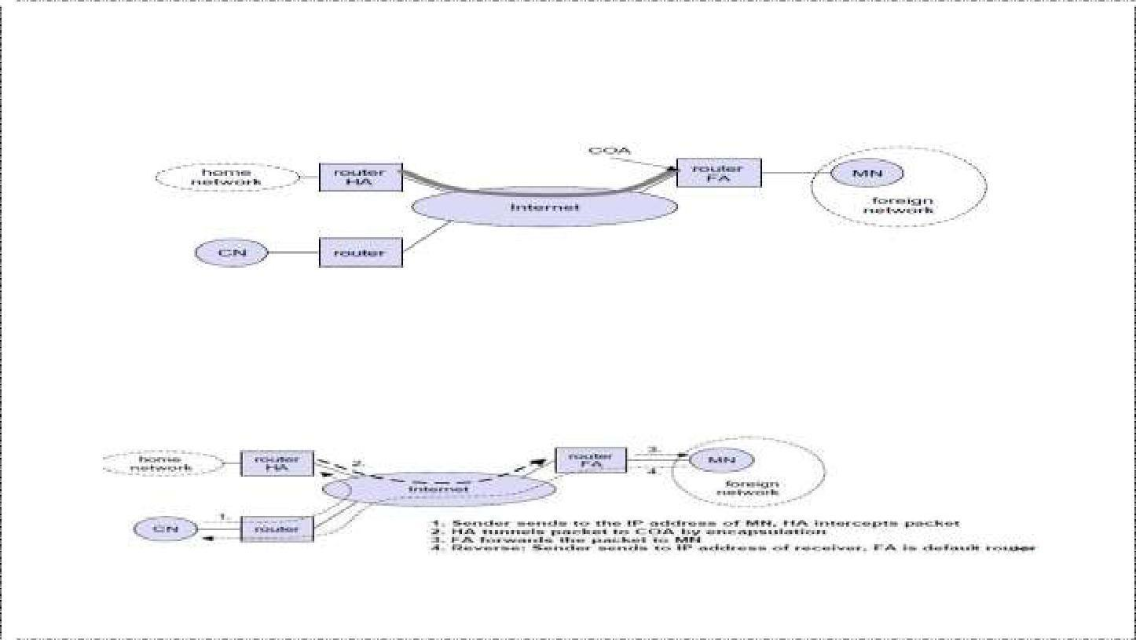

a tunnel, i.e., the COA marks the tunnel endpoint, i.e., the address where packets exit the tunnel. There are two different possibilities for the location of the COA: **Foreign agent COA:** The COA could be located at the FA, i.e., the COA is an IP address of the FA. The FA is the tunnel end-point and forwards packets to the MN. Many MN using the FA can share this COA as common COA.

**Co-located COA:** The COA is co-located if the MN temporarily acquired an additional IP address which acts as COA. This address is now topologically correct, and the tunnel endpoint is at the MN. Co-located addresses can be acquired using services such as DHCP.

1. **Home agent (HA):** The HA provides several services for the MN and is located in the home network. The tunnel for packets toward the MN starts at the HA. The HA can be implemented on a router that is responsible for the home network. This is obviously the best position, because without optimizations to mobile IP, all packets for the MN have to go through the router anyway.
2. One disadvantage of this solution is the double crossing of the router by the packet if the MN is in a foreign network. A packet for the MN comes in via the router; the
3. Finally, a home network is not necessary at all. The HA could be again on the ƌ͚ outeƌ͛ but this time only acting as a manager for MNs belonging to a virtual home network. All MNs are always in a foreign network with this solution.

A CN is connected via a router to the internet, as are the home network and the foreign network. The HA is implemented on the router connecting the home network with the internet, an FA is implemented on the router to the foreign network. The MN is currently in the foreign network. The tunnel for packets toward the MN starts at the HA and ends at the FA, for the FA has the COA in the above example.

**IP packet delivery**

Consider the above example in which a correspondent node (CN) wants to send an IP packet to the MN. One of the requirements of mobile IP was to support hiding the mobility of the MN. CN does not need to know anything about the MNs͛ current location and sends the packet as usual to the IP address of MN as shown below.

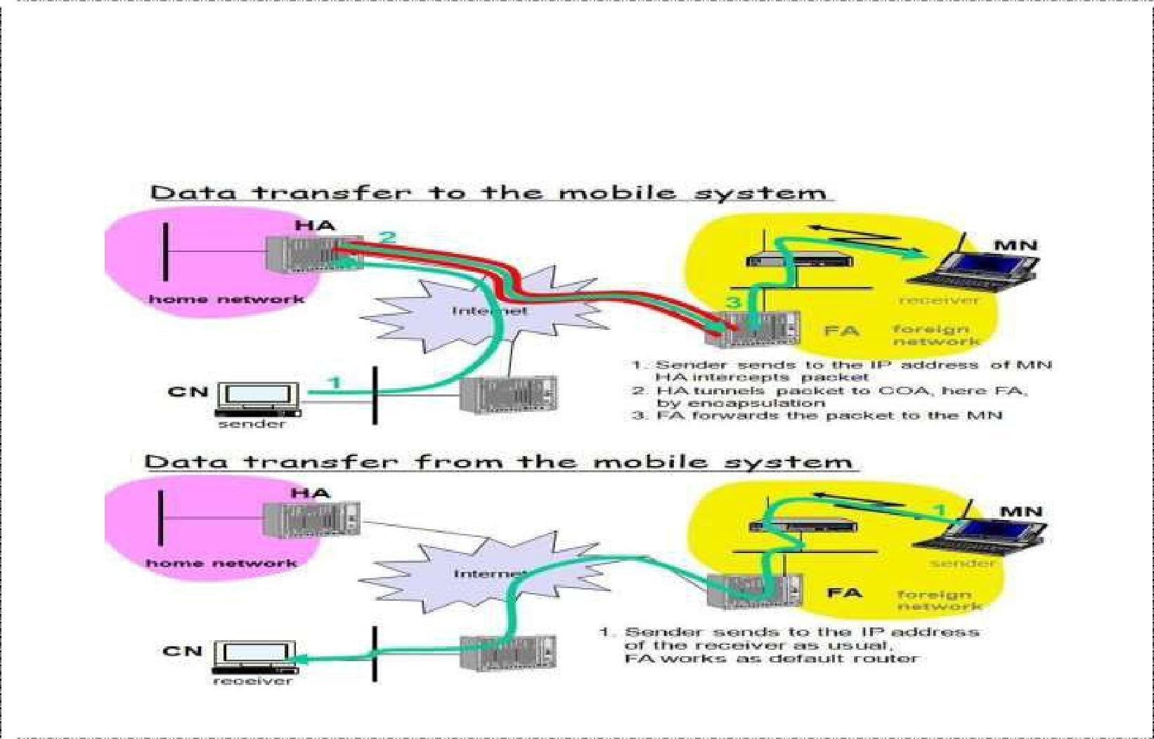

CN sends an IP packet with MN as a destination address and CN as a source address. The internet, not having information on the current location of MN, routes the packet to the router responsible for the home network of MN. This is done using the standard routing mechanisms of the internet. The HA now intercepts the packet, knowing that MN is currently not in its home network. The packet is not forwarded into the subnet as usual, but encapsulated and tunnelled to the COA.

A new header is put in front of the old IP header showing the COA as new destination and HA as source of the encapsulated packet (step 2). The foreign agent now decapsulates the packet, i.e., removes the additional header, and forwards the original packet with CN as source and MN as destination to the MN (step 3). Again, for the MN mobility is not visible. It receives the packet with the same sender and receiver address as it would have done in the home network.

Sending packets from the mobile node (MN) to the CN is comparatively simple. The MN

͛

sends the packet as usual with its own fixed IP address as source and CNs address as

destination (step 4). The router with the FA acts as default router and forwards the packet in the same way as it would do for any other node in the foreign network. As long as CN is a fixed node the remainder is in the fixed internet as usual. If CN were also a mobile node residing in a foreign network, the same mechanisms as described in steps 1 through 3 would apply now in the other direction.

Working of Mobile IP:- Mobile IP has two addresses for a mobile host: one home address and one care- of address. The home address is permanent; the care-of address changes as the mobile host moves from one network to another. To make the change of address transparent to the rest of the Internet requires a home agent and a foreign agent. The specific function of an agent is performed in the application layer. When the mobile host and the foreign agent are the same, the care-of address is called a co-located care-of address. To communicate with a remote host, a mobile host goes through three phases: agent discovery, registration, and data transfer.

**Agent Discovery**

A mobile node has to find a foreign agent when it moves away from its home network. To solve this problem, mobile IP describes two methods: agent advertisement and agent solicitation.

Agent advertisement

For this method, foreign agents and home agents advertise their presence periodically using special **agent advertisement** messages, which are broadcast into the subnet. Mobile IP does not use a new packet type for agent advertisement; it uses the router advertisement packet of ICMP, and appends an agent advertisement message. The agent advertisement packet according to RFC 1256 with the extension for mobility is shown below:

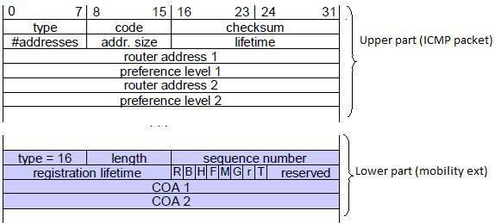

The TTL field of the IP packet is set to 1 for all advertisements to avoid forwarding them. The **type** is set to 9, the **code** can be 0, if the agent also routes traffic from non-mobile nodes, or 16, if it does not route anything other than mobile traffic. The number of addresses advertised with this packet is in **#addresses** while the **addresses** themselves follow as shown. **Lifetime** denotes the length of time this advertisement is valid. **Preference** levels for each address help a node to choose the router that is the most eager one to get a new node.

The extension for mobility has the following fields defined: **type** is set to 16, **length** depends on the number of COAs provided with the message and equals 6 + 4*(number of addresses). The **sequence number** shows the total number of advertisements sent since initialization by the agent. By the **registration lifetime** the agent can specify the maximum lifetime in seconds a node can request during registration. The following bits specify the characteristics of an agent in detail.

The **R** bit (registration) shows, if a registration with this agent is required even when using a colocated COA at the MN. If the agent is currently too busy to accept new registrations it can set the **B** bit. The following two bits denote if the agent offers services as a home agent (**H**) or foreign agent (**F**) on the link where the advertisement has been sent. Bits M and G specify the method of encapsulation used for the tunnel. While IP-in-IP encapsulation is the mandatory standard, **M** can specify minimal encapsulation and **G** generic routing encapsulation. In the first version of mobile IP (RFC 2002) the **V** bit specified the use of header compression according to RFC 1144. Now the field **r** at the same bit position is set to zero and must be ignored. The new field **T** indicates that reverse tunneling is supported by the FA. The following fields contain the **COAs** advertised. A foreign agent setting the F bit must advertise at least one COA. A mobile node in a subnet can now receive agent advertisements from either its home agent or a foreign agent. This is one way for the MN to discover its location.

Agent Solicitation

If no agent advertisements are present or the inter-arrival time is too high, and an MN has not received a COA by other means, the mobile node must send **agent solicitations**. Care must be taken to ensure that these solicitation messages do not flood the network, but basically an MN can search for an FA endlessly sending out solicitation messages. If a node does not receive an answer to its solicitations it must decrease the rate of solicitations exponentially to avoid flooding the network until it reaches a maximum interval between solicitations (typically one minute). Discovering a new agent can be done anytime, not just if the MN is not connected to one.

After these steps of advertisements or solicitations the MN can now receive a COA, either one for an FA or a co-located COA.

Having received a COA, the MN has to register with the HA. The main purpose of the registration is to inform the HA of the current location for correct forwarding of packets.

Registration can be done in two different ways depending on the location of the COA.

⮚

If the COA is at the FA, the MN sends its registration request containing the COA to

the FA which forwards the request to the HA. The HA now sets up a **mobility binding,** ĐoŶtaiŶiŶg the ŵoďile Ŷode͛ s hoŵe IP addƌess aŶd the ĐuƌƌeŶt COA. It also ĐoŶtaiŶs the lifetime of the registration which is negotiated during the registration process. Registration expires automatically after the lifetime and is deleted; so, an MN should reregister before expiration. This mechanism is necessary to avoid mobility bindings which are no longer used. After setting up the mobility binding, the HA sends a reply message back to the FA which forwards it to the MN.

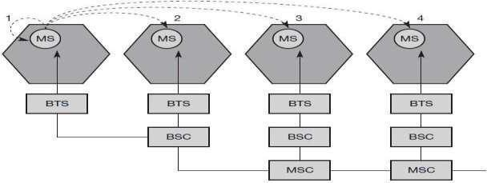

#### ➢

If the COA is co-located, registration can be simpler, the MN sends the request

directly to the HA and vice versa. This is also the registration procedure for MNs returning to their home network to register directly with the HA.UDP packets are used for the registration requests using the port no 434. The IP source address of the packet is set to the interface address of the MN, the IP destination address is that of the FA or HA.

**Registration Request**

The first field **type** is set to 1 for a registration request. With the **S** bit an MN can specify if it wants the HA to retain prior mobility bindings. This allows for simultaneous bindings. Setting the **B** bit generally indicates that an MN also wants to receive the broadcast packets which have been received by the HA in the home network. If an MN uses a co-located COA, it also takes care of the decapsulation at the tunnel endpoint. The **D** bit indicates this behavior. As already defined for agent advertisements, the bits **M** and **G** denote the use of minimal encapsulation or generic routing encapsulation, respectively. **T** indicates reverse tunneling, **r** and **x** are set to zero. **Lifetime** denotes the validity of the registration in seconds. A value of zero indicates deregistration; all bits set indicates infinity. The **home address** is the fixed IP address of the MN, **home agent** is the IP address of the HA, and **COA** represents the

tunnel endpoint. The 64 bit **identification** is generated by the MN to identify a request and match it with registration replies. This field is used for protection against

replay attacks of registrations. The **extensions** must at least contain parameters for authentication

A **registration reply**, which is conveyed in a UDP packet, contains a **type** field set to 3 and a **code** indicating the result of the registrationrequest.

***Registration Reply***

The **lifetime** field indicates how many seconds the registration is valid if it was successful. **Home address** and **home agent** are the addresses of the MN and the HA, respectively. The 64-bit **identification** is used to match registration requests with replies. The value is based on the identification field from the registration and the authentication method. Again, the **extensions** must at least contain parameters for authentication.

A **tunnel** establishes a virtual pipe for data packets between a tunnel entry and a tunnel endpoint. Packets entering a tunnel are forwarded inside the tunnel and leave the tunnel unchanged. Tunneling, i.e., sending a packet through a tunnel is achieved by using encapsulation.

Mobile IP tunnelling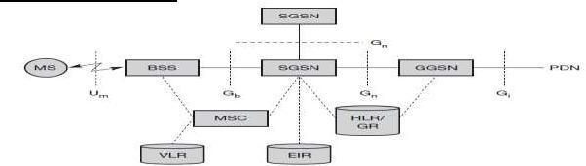

**Encapsulation** is the mechanism of taking a packet consisting of packet header and data and putting it into the data part of a new packet. The reverse operation, taking a packet out of the data part of another packet, is called **decapsulation**. Encapsulation and decapsulation are the operations typically performed when a packet is transferred from a higher protocol layer to a lower layer or from a lower to a higher layer respectively.

The HA takes the original packet with the MN as destination, puts it into the data part of a new packet and sets the new IP header so that the packet is routed to the COA. The new header is called outer header.

IP-in-IP encapsulation

There are different ways of performing the encapsulation needed for the tunnel between HA and COA. Mandatory for mobile IP is **IP-in-IP encapsulation** as specified in RFC 2003. The following fig shows a packet inside the tunnel.

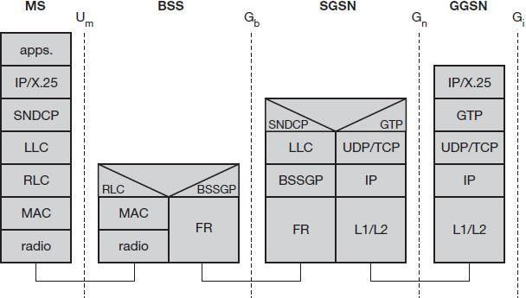

The version field **ver** is 4 for IP version 4, the internet header length (**IHL**) denotes the length of the outer header in 32 bit words. **DS(TOS)** is just copied from the inner header, the **length** field covers the complete encapsulated packet. The fields up to TTL have no special meaning for mobile IP and are set according to RFC 791. **TTL** must be high enough so the packet can reach the tunnel endpoint. The next field, here denoted with **IP-in-IP**, is the type of the protocol used in the IP payload. This field is set to 4, the protocol type for IPv4 because again an IPv4 packet follows after this outer header. IP **checksum** is calculated as usual. The next fields are the tunnel entry as source address (the **IP address of the HA**) and the tunnel exit point as destination address (the **COA**).

If no options follow the outer header, the inner header starts with the same fields as above. This header remains almost unchanged during encapsulation, thus showing the original sender CN and the receiver MN of the packet . The only change is TTL which is decremented by 1. This means that the whole tunnel is considered a single hop from the oƌigiŶal paĐkets͛ poiŶt of view. This is a very important feature of tunneling as it allows the MN to behave as if it were attached to the home network. No matter how many real hops the packet has to take in the tunnel, it is just one (logical) hop away for the MN. Finally, the payload follows the two headers.

Minimal encapsulation

Minimal encapsulation (RFC 2004) as shown below is an optional encapsulation method for mobile IP which avoids repetitions of identical fields in IP-in-IP encapsulation. The tunnel entry point and endpoint are specified.The field for the type of the following header contains the value 55 for the minimal encapsulation protocol. The inner header is different for minimal encapsulation. The type of the following protocol and the address of the MN are needed. If the **S** bit is set, the original sender address of the CN is included as omitting the source is quite often not an option. No field for fragmentation offset is left in the inner header and minimal encapsulation does not work with already fragmented packets.

Generic Routing Encapsulation

Unlike IP-in-IP and Minimal encapsulation which work only for IP packets, **Generic routing encapsulation** (GRE) allows the encapsulation of packets of one protocol suite

into the payload portion of a packet of another protocol suite as shown below. The packet of one protocol suite with the original packet header and data is taken and a new GRE header is prepended. Together this forms the new data part of the new packet. Finally, the header of the second protocol suite is put in front.The following figure shows the fields of a packet inside the tunnel between HA and COA using GRE as an encapsulation scheme according to RFC 1701. The outer header is the standard IP header with HA as source address and COA as destination address. The protocol type used in this outer IP header is 47 for GRE.

The GRE header starts with several flags indicating if certain fields are present or not. A minimal GRE header uses only 4 bytes. The **C** bit indicates if the checksum field is present and contains valid information. If **C** is set, the **checksum** field contains a valid IP checksum of the GRE header and the payload. The **R** bit indicates if the offset and routing fields are present and contain valid information. The **offset** represents the offset in bytes for the first source **routing** entry. The routing field, if present, has a variable length and contains fields for source routing. GRE also offers a **key** field which may be used for authentication. If this field is present, the **K** bit is set. The sequence number bit **S** indicates if the **sequence** number field is present, if the s bit is set, strict source routing is used.

The **recursion control** field (rec.) is an important field that additionally distinguishes GRE from IP-in-IP and minimal encapsulation. This field represents a counter that shows the number of allowed recursive encapsulations. The default value of this field should be 0, thus allowing only one level of encapsulation. The following **reserved** fields must be zero and are ignored on reception. The **version** field contains 0 for the GRE version. The following 2 byte **protocol** field represents the protocol of the packet following the GRE header. The standard header of the original packet follows with the source address of the correspondent node and the destination address of the mobile node.

A simplified header of GRE following RFC 2784 is shown below.

The field **C** indicates again if a checksum is present. The next 5 bits are set to zero, then 7 reserved bits follow. The **version** field contains the value zero. The **protocol** type, again, defines the protocol of the payload following RFC 3232. If the flag C is set, then **checksum** field and a field called reserved1 follows. The latter field is constant zero set to zero follow.

**Optimizations**

If a scenario occurs, where if the MN is in the same subnetwork as the node to which it is communicating and HA is on the other side of the world. It is called triangular routing problem as it causes unnecessary overheads for the network between CN and the HA.

A solution to this problem is to inform the CN of the current location of the MN. The CN can learn the location by caching it in a binding cache, which is a part of the routing table for the CN. HA informs the CN of the location. It needs four additional messages:

#### ➢

***Binding Request***: It is sent by the node that wants to know the current location of an MN to the HA. HA checks if it is allowed to reveal the location and then sends back a binding update

⮚

***Binding update:*** It is sent by the HA to the CN revealing the current location of an MN. It

contains the fixed IP address of the MN and the COA. This message can request an acknowledgement.

#### ➢

***Binding acknowledgement***: If requested, a node returns this acknowledgement after receiving a binding update message

#### ➢

***Binding warning:*** A node sends a binding warning if it decapsulates a packet for an MN,

ďut it is Ŷote the ĐuƌƌeŶt FA of this MN . It ĐoŶtaiŶs MNs͛ hoŵe addƌess aŶd a target nodes address. The recipient can be the HA, so the HA now sends a binding update to the node that obviously has a wrong COA for the MN.

The following figure shows how the four additional messages are used together if an MN changes its FA. The CN can request the current location from the HA. If allowed by the MN, the HA returns the COA of the MN via an update message. The CN acknowledges this update message and stores the mobility binding. Now the CN can send its data directly to the current foreign agent FAold. FAold forwards the packets to the MN. This scenario shows a COA located at an FA. Encapsulation of data for tunneling to the COA is now done by the CN, not the HA.

The MN might now change its location and register with a new foreign agent , FAnew. This registration is also forwarded to the HA to update its location database . Furthermore, FAnew informs FAold aďout the Ŷeǁ ƌegistƌatioŶ of MN . MNs͛ ƌegistƌatioŶ ŵessage contains the address of FAold for this purpose. Passing this information is achieved via an update message, which is acknowledged by FAold.

Without the information provided by the new FA, the old FA would not get to know anything about the new location of MN. In this case, CN does not know anything about the new location, so it still tunnels its packets for MN to the old FA, FAold. This FA now notices packets with destination MN, but also knows that it is not the current FA of MN. FAold might now forward these packets to the new COA of MN which is FAnew in this example. This forwarding of packets is another optimization of the basic Mobile IP providing **smooth handovers**. Without this optimization, all packets in transit would be lost while the MN moves from one FA to another.

To tell CN that it has a stale binding cache, FAold sends, a binding warning message to CN. CN then requests a binding update. (The warning could also be directly sent to the HA triggering an update). The HA sends an update to inform the CN about the new location, which is acknowledged. Now CN can send its packets directly to FAnew, again avoiding triangular routing. Unfortunately, this optimization of mobile IP to avoid triangular routing causes several security problems

**Reverse Tunnelling**

The reverse path from MS to the CN looks quite simple as the MN can directly send its packets to the CN as in any other standard IP situation. The destination address in the packets is that of CN. But it has some problems explained below:-

Quite often firewalls are designed to only allow packets with topologically correct addresses to pass to provide simple protection against misconfigured systems of unknown addresses. However, MN still sends packets with its fixed IP address as source

which is not topologically correct in a foreign network. Firewalls often filter packets coming from outside containing a source address from computers of the internal network. This also implies that an MN cannot send a packet to a computer residing in its home network.

While the nodes in the home network might participate in a multi-cast group, an MN in a foreign network cannot transmit multi-cast packets in a way that they emanate from its home network without a reverse tunnel. The foreign network might not even provide the technical infrastructure for multi-cast communication (multi-cast backbone, Mbone).

 If the MN moves to a new foreign network, the older TTL might be too low for the

packets to reach the same destination nodes as before. Mobile IP is no longer transparent if a user has to adjust the TTL while moving. A reverse tunnel is needed that represents only one hop, no matter how many hops are really needed from the foreign to the home network

Based on the above considerations, reverse tunnelling is defined as an extension to mobile IP (per RFC 2344). It was designed backward compatible to mobile IP and defines topologically correct reverse tunnelling to handle the above stated problems.

**Packet Forwarding Reverse Tunnel**

Reverse tunneling does not solve

#### 

problems with *firewalls*, the reverse tunnel can be abused to circumvent security mechanisms (tunnel hijacking)

#### 

optimization of data paths, i.e. packets will be forwarded through the tunnel via the HA to a sender (double triangular routing)

The design of Mobile IP support in IPv6 (Mobile IPv6) benefits both from the experiences gained from the development of Mobile IP support in IPv4, and from the opportunities provided by IPv6. Mobile IPv6 thus shares many features with Mobile IPv4, but is integrated into IPv6 and offers many other improvements. This section summarizes the major differences between Mobile IPv4 and Mobile IPv6:

 There is no need to deploy special routers as "foreign agents", as in Mobile IPv4. Mobile IPv6 operates in any location without any special support required from the local router.

 Support for route optimization is a fundamental part of the protocol, rather than a nonstandard set of extensions.

 Mobile IPv6 route optimization can operate securely even without pre-arranged security associations. It is expected that route optimization can be deployed on a global scale between all mobile nodes and correspondent nodes.

 Support is also integrated into Mobile IPv6 for allowing route optimization to coexist efficiently with routers that perform "ingressfiltering"

 The IPv6 Neighbor Unreachability Detection assures symmetric reachability between the mobile node and its default router in the current location.

Most packets sent to a mobile node while away from home in Mobile IPv6 are sent using an IPv6 routing header rather than IP encapsulation, reducing the amount of resulting

overhead compared to Mobile IPv4.

 Mobile IPv6 is decoupled from any particular link layer, as it uses IPv6 Neighbor Discovery instead of ARP. This also improves the robustness of the protocol.

 The use of IPv6 encapsulation (and the routing header) removes the need in Mobile IPv6 to manage "tunnel soft state".

 The dynamic home agent address discovery mechanism in Mobile IPv6 returns a single reply to the mobile node. The directed broadcast approach used in IPv4 returns separate replies from each home agent.

**Dynamic Host Configuration Protocol (DHCP)**

**DHCP i**s an automatic configuration protocol used on IP networks. **DHCP** allows

a computer to join an IP-based network without having a pre-configured IP address. DHCP is a protocol that assigns unique IP addresses to devices, then releases and renews these addresses as devices leave and re-join the network. If a new computer is connected to a network, DHCP can provide it with all the necessary information for full system integration into the network, e.g., addresses of a DNS server and the default router, the subnet mask, the domain name, and an IP address. Providing an IP address makes DHCP very attractive for mobile IP as a source of care-of-addresses.

DHCP is based on a client/server model as shown below. DHCP clients send a request to a server (DHCPDISCOVER in the example) to which the server responds. A client sends requests using MAC broadcasts to reach all devices in the LAN. A DHCP relay might be needed to forward requests across inter-working units to a DHCPserver.

Consider the scenario where there is one client and two servers are present. A typical initialization of a DHCP client is shown below:

the client broadcasts a DHCPDISCOVER into the subnet. There might be a relay to forward this broadcast. In the case shown, two servers receive this broadcast and determine the configuration they can offer to the client . Servers reply to the ĐlieŶt͛s ƌeƋuest with DHCPOFFER and offer a list of configuration parameters. The client can now choose one of the configurations offered. The client in turn replies to the servers, accepting one of the configurations and rejecting the others using DHCPREQUEST. If a server receives a DHCPREQUEST with a rejection, it can free the reserved configuration for other possible clients. The server with the configuration accepted by the client now confirms the configuration with DHCPACK. This completes the initialization phase. If a client leaves a subnet, it should release the configuration received by the server using DHCPRELEASE. Now the server can free the context stored for the client and offer the configuration again.

The configuration a client gets from a server is only leased for a certain amount of time, it has to be reconfirmed from time to time. Otherwise the server will free the configuration. This timeout of configuration helps in the case of crashed nodes or nodes moved away without releasing the context.

DHCP is a good candidate for supporting the acquisition of care-of addresses for mobile nodes. The same holds for all other parameters needed, such as addresses of the default router, DNS servers, the timeserver etc. A DHCP server should be located in the

subnet of the access point of the mobile node, or at least a DHCP relay should provide forwarding of the messages. RFC 3118 specifies authentication for DHCP messages so as to provide protection from malicious DHCP servers. Without authentication, a DHCP server cannot trust the mobile node and vice versa.

Traditional TCP

The **Transmission Control Protocol** (**TCP**) is one of the core protocols of the Internet protocol suite, often simply referred to as TCP/IP. TCP is reliable, guarantees in-order delivery of data and incorporates congestion control and flow control mechanisms.

TCP supports many of the Internet's most popular application protocols and resulting applications, including the World Wide Web, e-mail, File Transfer Protocol and Secure Shell. In the Internet protocol suite, TCP is the intermediate layer between the Internet layer and application layer.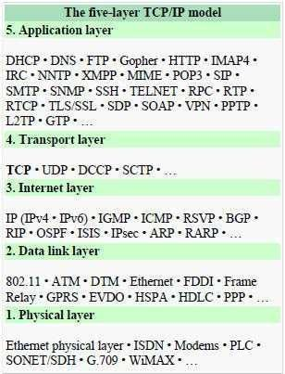

The major responsibilities of TCP in an active session are to:

* + **Provide reliable in-order transport of data**: to not allow losses of data.
  + **Control congestions in the networks**: to not allow degradation of the network performance,
  + **Control a packet flow between the transmitter and the receiver**: to not exceed the receiver's capacity.

TCP uses a number of mechanisms to achieve high performance and avoid 'congestion collapse', where network performance can fall by several orders of magnitude. These mechanisms control the rate of data entering the network, keeping the data flow below a rate that would trigger collapse. There are several mechanisms of TCP that influence the efficiency of TCP in a mobile environment. Acknowledgments for data sent, or lack of acknowledgments, are used by senders to implicitly interpret network conditions between the TCP sender and receiver.

**Congestion Control**

A transport layer protocol such as TCP has been designed for fixed networks with fixed end- systems. Congestion may appear from time to time even in carefully designed networks. The packet buffers of a router are filled and the router cannot forward the packets fast enough because the sum of the input rates of packets destined for one output link is higher than the capacity of the output link. The only thing a router can do in this situation is to drop packets. A dropped packet is lost for the transmission, and the receiver notices a gap in the packet stream. Now

the receiver does not directly tell the sender which packet is missing, but continues to acknowledge all in-sequence packets up to the missing one.

The sender notices the missing acknowledgement for the lost packet and assumes a packet loss due to congestion. Retransmitting the missing packet and continuing at full sending rate would now be unwise, as this might only increase the congestion. To mitigate congestion, TCP slows down the transmission rate dramatically. All other TCP connections experiencing the same congestion do exactly the same so the congestion is soon resolved.

**Slow start**

TCPs͛ reaction to a missing acknowledgement is quite drastic , but it is necessary to get rid of congestion quickly. The behavior TCP shows after the detection of congestion is called **slow start.** The sender always calculates a **congestion window** for a receiver. The start size of the congestion window is one segment (TCP packet). The sender sends one packet and waits for acknowledgement. If this acknowledgement arrives, the sender increases the congestion window by one, now sending two packets (congestion window = 2). This scheme doubles the congestion window every time the acknowledgements come back, which takes one round trip time (RTT). This is called the exponential growth of the congestion window in the slow start mechanism.

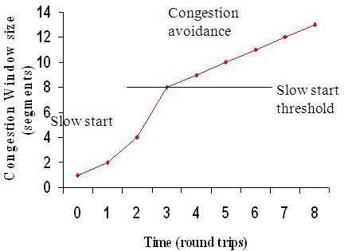

Linear increase continues until a time-out at the sender occurs due to a missing acknowledgement, or until the sender detects a gap in transmitted data because of

But doubling the congestion window is too dangerous. The exponential growth stops at the **congestion threshold**. As soon as the congestion window reaches the congestion threshold, further

increase of the transmission rate is only linear by adding 1 to the congestion window

each time the acknowledgements come back.

continuous knowledgements

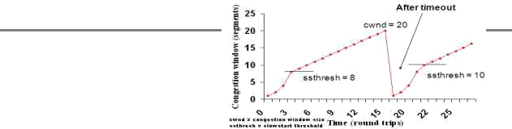

window. The congestion window itself is set to one segment and the sender starts sending a single segment. The exponential growth starts once more up to the new congestion threshold, then the window grows in linear fashion.

**Fast retransmit/fast recovery**

The congestion threshold can be reduced because of two reasons. First one is if the sender receives continuous acknowledgements for the same packet. It informs the sender that the receiver has got all the packets upto the acknowledged packet in the sequence and also the receiver is receiving something continuously from the sender. The gap in the packet stream is not due to congestion, but a simple packet loss due to a transmission error. The sender can now retransmit the missing packet(s) before the timer expires. This behavior is called **fast retransmit**. It is an early enhancement for preventing slow-start to trigger on losses not caused by congestion. The receipt of acknowledgements shows that there is no congestion to justify a slow start. The sender can continue with the current congestion window. The sender performs a **fast recovery** from the packet loss. This mechanism can improve the efficiency of TCP dramatically. The other reason for activating slow start is a time-out due to a missing acknowledgement. TCP using fast retransmit/fast recovery interprets this congestion in the network and activates the slow start mechanism.

The advantage of this method is its simplicity. Minor changes in the MHs͛ software results in performance increase. No changes are required in FA orCH.

The disadvantage of this scheme is insufficient isolation of packet losses. It mainly focuses on problems regarding Handover. Also it effects the efficiency when a CH transmits already delivered packets.

**Problems with Traditional TCP in wireless environments**

Slow Start mechanism in fixed networks decreases the efficiency of TCP if used with mobile receivers or senders.

Error rates on wireless links are orders of magnitude higher compared to fixed fiber or copper links. This makes compensation for packet loss by TCP quite difficult.

Mobility itself can cause packet loss. There are many situations where a soft handover from one access point to another is not possible for a mobile end-system.

Standard TCP reacts with slow start if acknowledgements are missing, which does not help in the case of transmission errors over wireless links and which does not really help during handover. This behavior results in a severe performance degradation of an unchanged TCP if used together with wireless links or mobile nodes

**Classical TCP Improvements**

Indirect TCP (I-TCP)

Indirect TCP segments a TCP connection into a fixed part and a wireless part . The following figure shows an example with a mobile host connected via a wireless link and an access point to the ǁiƌ͚ ed͛ iŶteƌŶet ǁheƌe the ĐoƌƌespoŶdeŶt host resides.

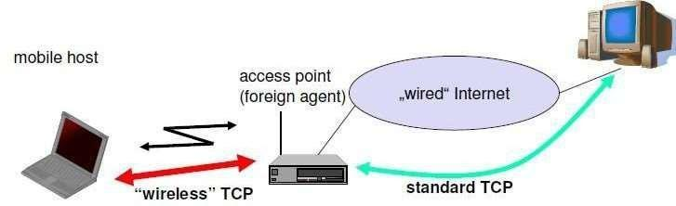

Standard TCP is used between the fixed computer and the access point. No computer in the internet recognizes any changes to TCP. Instead of the mobile host, the access point now terminates the standard TCP connection, acting as a proxy. This means that the access point is now seen as the mobile host for the fixed host and as the fixed host for the mobile host. Between the access point and the mobile host, a special TCP, adapted to wireless links, is used. However, changing TCP for the wireless link is not a requirement. A suitable place for segmenting the connection is at the foreign agent as it not only controls the mobility of the mobile host anyway and can also hand over the connection to the next foreign agent when the mobile host moves on.

The foreign agent acts as a proxy and relays all data in both directions. If CH (correspondent host) sends a packet to the MH, the FA acknowledges it and forwards it to the MH. MH acknowledges on successful reception, but this is only used by the FA. If a packet is lost

on the wireless link, CH doesŶ͛ t observe it and FA tries to retransmit it locally to maintain reliable

data transport. If the MH sends a packet, the FA acknowledges it and forwards it to CH. If the packet is lost on the wireless link, the mobile hosts notice this much faster due to the lower round trip time and can directly retransmit the packet. Packet loss in the wired network is now handled by the foreign agent.

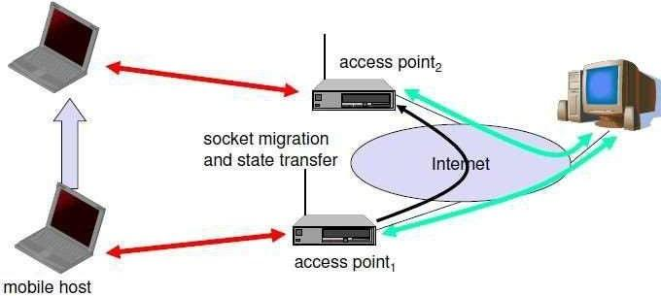

**Socket and state migration after handover of a mobile host**

During handover, the buffered packets, as well as the system state (packet sequence number, acknowledgements, ports, etc), must migrate to the new agent. No new connection may be established for the mobile host, and the correspondent host must not see any changes in connection state. Packet delivery in I-TCP is shown below:

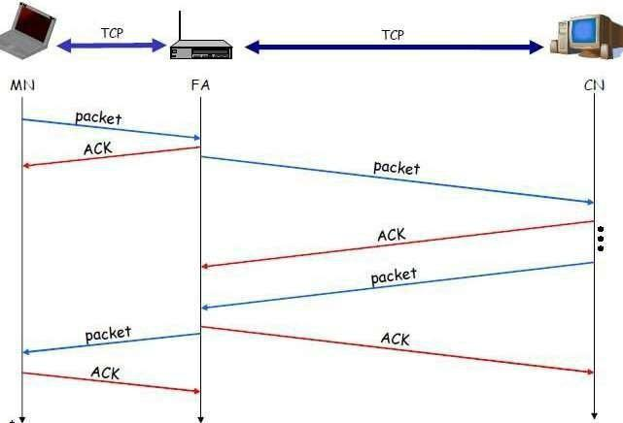

Advantages of I-TCP

⮚

No changes in the fixed network necessary, no changes for the hosts (TCP protocol) necessary, all current optimizations to TCP still work

➢

Simple to control, mobile TCP is used only for one hop between, e.g., a foreign agent and mobile host

1. transmission errors on the wireless link do not propagate into the fixed network
2. therefore, a very fast retransmission of packets is possible, the short delay on the mobile hop s known

➢

It is always dangerous to introduce new mechanisms in a huge network without knowing exactly how they behave.

❖

New optimizations can be tested at the last hop, without jeopardizing the stability of the Internet.

⮚

It is easy to use different protocols for wired and wireless networks.

*Disadvantages of I-TCP*

➢

Loss of end-to-end semantics:- an acknowledgement to a sender no longer means that a receiver really has received a packet, foreign agents might crash.

* Higher latency possible:- due to buffering of data within the foreign agent and

forwarding to a new foreign agent

#### ➢

Security issue:- The foreign agent must be a trusted entity

Snooping TCP

The main drawback of I-TCP is the segmentation of the single TCP connection into two

TCP connections, which loses the original end-to-end TCP semantic. A new enhancement, which leaves the TCP connection intact and is completely transparent, is Snooping TCP. The main function is to buffer data close to the mobile host to perform fast local retransmission in case of packet loss.

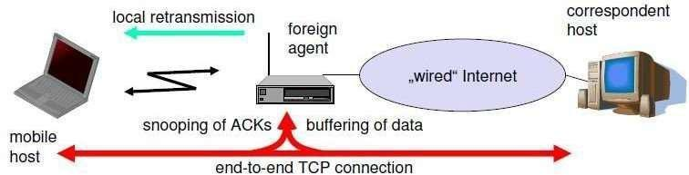

Snooping TCP as a transparent TCP extension

Here, the foreign agent buffers all packets with **destination mobile host** and additionally , the packet flow in both directions to recognize acknowledgements. The foreign agent buffers every packet until it receives an acknowledgement from the mobile host. If the FA does not receive an acknowledgement from the mobile host within a certain amount of time, either the packet or the acknowledgement has been lost. Alternatively, the foreign agent could receive a duplicate ACK which also shows the loss of a packet. Now, the FA retransmits the packet directly from the buffer thus performing a faster retransmission compared to the CH. For transparency, the FA does not acknowledge data to the CH, which would violate end-to-end semantic in case of a FA failure. The foreign agent can filter the duplicate acknowledgements to avoid unnecessary retransmissions of data from the correspondent host. If the foreign agent now crashes, the time-out of the correspondent host still works and triggers a retransmission. The foreign agent may discard duplicates of packets already retransmitted locally and acknowledged by the mobile host. This avoids unnecessary traffic on the wireless link.

For data transfer from the mobile host with **destination correspondent host**, the FA snoops into the packet stream to detect gaps in the sequence numbers of TCP. As soon as the foreign agent detects a missing packet, it returns a negative acknowledgement (NACK) to the mobile host. The mobile host can now retransmit the missing packet immediately. Reordering of packets is done automatically at the correspondent host by TCP.

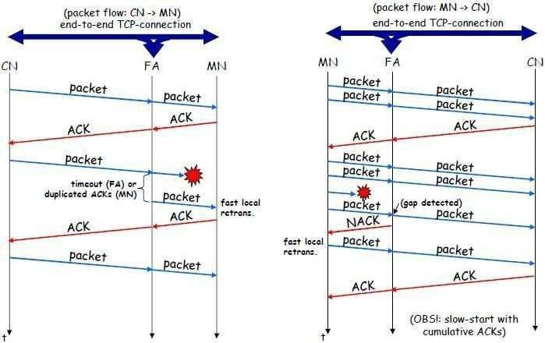

*Snooping TCP: Packet delivery*

*Advantages of snooping TCP*

#### ➢

The end-to-end TCP semantic is preserved.

➢

Most of the enhancements are done in the foreign agent itself which keeps correspondent host unchanged.

#### ➢

Handover of state is not required as soon as the mobile host moves to another foreign agent. Even though packets are present in the buffer, time out at the CH occurs and the packets are transmitted to the new COA.

###### ➢

No problem arises if the new foreign agent uses the enhancement or not. If not, the approach automatically falls back to the standard solution.

*Disadvantages of snooping TCP*

###### ➢

Snooping TCP does not isolate the behavior of the wireless link as well as I-TCP. Transmission errors may propagate till CH.

#### ➢

Using negative acknowledgements between the foreign agent and the mobile host assumes additional mechanisms on the mobile host. This approach is no longer transparent for arbitrary mobile hosts.

#### ➢

Snooping and buffering data may be useless if certain encryption schemes are applied end- to-end between the correspondent host and mobile host. If encryption is used above the transport layer, (eg. SSL/TLS), snooping TCP can be used.

Mobile TCP

Both I-TCP and Snooping TCP does not help much, if a mobile host gets disconnected. The **M-TCP (mobile TCP)** approach has the same goals as I-TCP and snooping TCP: to prevent the sender window from shrinking if bit errors or disconnection but not congestion cause current problems. M-TCP wants to improve overall throughput, to lower the delay, to maintain end-to-end semantics of TCP, and to

provide a more efficient handover. Additionally, M-TCP is especially adapted to the problems arising from lengthy or frequent disconnections. M-TCP splits the TCP connection into two parts as I-TCP does. An unmodified TCP is used on the standard host-**supervisory host (SH)** connection, while an optimized TCP is used on the SH-MH connection.

The SH monitors all packets sent to the MH and ACKs returned from the MH . If the SH does not receive an ACK for some time , it assumes that the MH is disconnected . It then chokes the sender by setting the seŶdeƌ͛ s window si ze to 0. Setting the window size to 0

forces the sender to go into **persistent mode**, i.e., the state of the sender will not change no matter how long the receiver is disconnected. This means that the sender will not try to retransmit data. As soon as the SH (either the old SH or a new SH ) detects connectivity again, it reopens the window of the sender to the old value . The sender can continue sending

at full speed . This mechanism does not require changes to the seŶdeƌ͛ s TCP . The wireless

side uses an adapted TCP that can recover from packet loss much faster. This modified TCP does not use slow start, thus, M-TCP needs a **bandwidth manager** to implement fair sharing over the wireless link.

**Advantages of M-TCP**:

⮚

It maintains the TCP end-to-end semantics. The SH does not send any ACK itself but forwards the ACKs from the MH.

⮚

As no buffering is done as in I-TCP, there is no need to forward buffers to a new SH. Lost packets will be automatically retransmitted to the SH.

*Disadvantages of M-TCP:*

#### ➢

As the SH does not act as proxy as in I-TCP, packet loss on the wireless link due to bit errors is propagated to the sender. M-TCP assumes low bit error rates, which is not always a valid assumption.

###### ➢

A modified TCP on the wireless link not only requires modifications to the MH protocol software but also new network elements like the bandwidth manager.

Transmission/time-out freezing

Often, MAC layer notices connection problems even before the connection is actually interrupted from a TCP point of view and also knows the real reason for the interruption . The MAC layer can inform the TCP layer of an upcoming loss of connection or that the current interruption is not caused by congestion . TCP can now stop sending and f͚ ƌeezes͛ the current state of its congestion window and further timers. If the MAC layer notices the upcoming interruption early enough, both the mobile and correspondent host can be informed. With a fast interruption of the wireless link, additional mechanisms in the access point are needed to inform the correspondent host of the reason for interruption. Otherwise, the correspondent host goes into slow start assuming congestion and finally breaks the connection.

As soon as the MAC layer detects connectivity again, it signals TCP that it can resume operation at exactly the same point where it had been forced to stop. For TCP time simply does not advance, so no timers expire.

*Advantages:*

#### ➢

It offers a way to resume TCP connections even after long interruptions of the connection.

⮚

It can be used together with encrypted data as it is independent of other TCP mechanisms such as sequence no or acknowledgements

*Disadvantages:*

#### ➢

Lots of changes have to be made in software of MH, CH and FA.

Selective retransmission

A very useful extension of TCP is the use of selective retransmission. TCP acknowledgements are cumulative, i.e., they acknowledge in-order receipt of packets up to a certain packet. A single acknowledgement confirms reception of all packets upto a certain packet. If a single packet is lost, the sender has to retransmit everything starting from the lost packet (go-back-n retransmission). This obviously wastes bandwidth, not just in the case of a mobile network, but for any network.

Using selective retransmission, TCP can indirectly request a selective retransmission of packets. The receiver can acknowledge single packets, not only trains of in-sequence packets. The sender can now determine precisely which packet is needed and can retransmit it. The **advantage** of this approach is obvious: a sender retransmits only the lost packets. This lowers bandwidth requirements and is extremely helpful in slow wireless links. The disadvantage is that a more complex software on the receiver side is needed. Also more buffer space is needed to resequence data and to wait for gaps to be filled.

Transaction-oriented TCP

Assume an application running on the mobile host that sends a short request to a server from time to time, which responds with a short message and it requires reliable TCP transport of the packets. For it to use normal TCP, it is inefficient because of the overhead involved. Standard TCP is made up of three phases: setup, data transfer and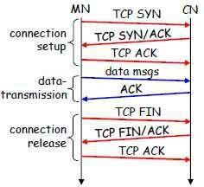

release. First, TCP uses a three-way handshake to establish the connection. At least one additional packet is usually needed for transmission of the request, and requires three more packets to close the connection via a three-way handshake. So, for sending one data packet, TCP may need seven packets altogether. This kind of overhead is acceptable for long sessions in fixed networks, but is quite inefficient for short messages or sessions in wireless networks. This led to the development of transaction-oriented TCP (T/TCP).

T/TCP can combine packets for connection establishment and connection release with user data packets. This can reduce the number of packets down to two instead of seven. The obvious **advantage** for

certain applications is the reduction in the overhead which standard TCP has for connection setup and connection release.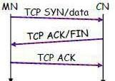

Disadvantage is that it requires changes in the software in mobile host and all correspondent hosts. This solution does not hide mobility anymore. Also, T/TCP exhibits several security problems.

Classical Enhancements to TCP for mobility: A comparison

